**SmartBracket™ Marketing Performance Report &   
Strategy Consultation - March Madness Campaign Analysis (2021-2025)**

**Executive Summary:**

This report analyzes the marketing performance of SmartBracket™ campaigns from 2021 to 2025, focusing on marketing campaigns and resulting sales data. Despite increased marketing expenditure over the years, sales have diminished, indicating a need for strategic adjustments rather than simply increasing spending. The competitive landscape has intensified with the emergence of numerous AI-based bracket prediction models, including free options, further challenging the market position of SmartBracket™. The analysis suggests a pivot in marketing strategy is necessary to regain traction and achieve sustainable sales growth. We recommend **not increasing marketing spend in the current consumer campaign format** and instead focusing on a revised strategy centered on differentiation, more targeted marketing, and increasing marketing focus on our unique Supported Intelligence Rapid Recursive Toolbox product positioning.

**1. Performance Analysis:**

**1.1 Email Marketing Campaign Performance (Mailchimp Data):**

We analyzed the Mailchimp campaign reports from 2024 and 2025. In Appendix 2, you can see further details of each of the 2025 outreach campaign emails. Here are key observations:

* **Consistent Open Rates:** Open rates across campaigns in both years are relatively consistent, ranging from ~29% to ~40%. “An MVP Offer For You!” (2024) achieved the highest open rate (40.5%). This suggests subject lines are reasonably effective at capturing initial attention.
* **Declining Click-Through Rates (CTR):** Click-through rates are low across all campaigns, generally ranging from 1.5% to 5.1% of recipients clicked. “An MVP Offer For You!” (2024) had the highest CTR (5.1%), while “Smartbracket $1 FORBES” (2025) had the lowest (1.5%). This indicates that while emails are being opened, the marketing content is not effectively driving clicks to purchase or engage further. Past customers are coming back less and less in response to our email marketing targeted campaigns.
* **URL Click Performance:**
  + **Consistent Interest in SmartBracket Website:**   
    https://www.smartbracket.io/ and https://app.smartbracket.io/bracket are consistently the top clicked URLs across campaigns, indicating user interest in our core product and application.
  + **Limited Social Media Engagement:** Clicks on social media URLs (Twitter, Facebook) are minimal or non-existent across most campaigns, suggesting our social media engagement is limited. Similarly, LinkedIn engagement, even with boosting, is curtailed by “the algorithm”, causing limited visibility and click-through interest and purchases of SmartBracket.
  + **Forbes Article Engagement:** The older Forbes article URL (https://www.forbes.com/...) saw significant clicks in the “Smartbracket Coming Soon 2025” campaign, suggesting content related to bracket strategy or external validation is still engaging.
* **Campaign Comparison (2024 vs 2025):** Comparing similar campaigns across years is difficult as the campaign titles and subjects vary. However, broadly comparing the overall email performance in 2024 vs 2025 does not show a clear improvement in engagement metrics despite some increased marketing efforts.

**1.2. Social Media Performance Data**

**1.2.1 X/Twitter:**

* **X Post Views:** 53 (Total for Campaign Period)
* **X Post Engagements (Likes, Retweets, Replies):** 5 (Total for Campaign Period)

**1.2.2 Facebook/Meta:**

* **Facebook/Meta Post Reach:** 15 (Total for Campaign Period)
* **Facebook/Meta Post Engagements (Likes, Reactions, Comments, Shares):** 0 (Total for Campaign Period)

**1.2.3 Instagram:**

* **Instagram Page Follower Growth (during campaign period):** 51

**1.2.4. LinkedIn:**

* **LinkedIn Post Views:** 172 (Total for Campaign Period) from Supported Intelligence, 586 (Total for Campaign Period) from Dan Lipsy posts
* **LinkedIn Post Engagements (Likes, Reactions, Comments, Shares):** 3 (Total for Campaign Period)
* **LinkedIn Link Clicks to SmartBracket Website:** 24 (Total for Campaign Period)

**Data Sources:**

* **Overview:** Social media strategy and social media posts and emails are detailed in Appendix 1.
* **X/Twitter:** Metrics derived from Appendix 6, which detailed impressions (views) and engagements across five posts.
* **Facebook/Meta:** Metrics sourced from Appendix 5, providing post reach, engagements, and followers reached during the campaign period.
* **Instagram:** Data extracted from Appendix 4, which listed 51 followers, assumed to represent growth during the campaign period.
* **LinkedIn:** Comprehensive metrics provided in Appendix 3, covering post views, engagements, link clicks, and followers reached during the campaign period.

**1.2 Sales Trends (Stripe Data 2021-2025):**

Analysis of Stripe data across the years reveals the following trends:

* **Decreasing Transaction Count:** The number of transactions has generally decreased from 2021 to 2025.
  + 2021: 56 transactions
  + 2022: 99 transactions
  + 2023: 137 transactions
  + 2024: 109 transactions
  + 2025: 44 transactions
* **Consistent Average Revenue Per User (ARPU):** The average revenue per user has remained relatively stable across the years, around $4.70 - $4.79. With lower conversion volume, it seems there is more limited interest, largely due to the many free options to get a decent bracket, including several that are available by prompted conversations with various AI models.
* **Coupon Usage Patterns:**
  + **WELCOMEBACK:** Consistently used across years, indicating some effectiveness for repeat customer retention. However, the number of WELCOMEBACK coupon users is relatively small compared to overall transactions. Around 1.5-2% have often responded in years past. This year, with more emails out, under 0.5% signed up.
  + **ROTOWIRE:** Also consistently used, suggesting partnerships or promotions with Rotowire are driving some sales. However, we netted 10 customers from a $2500 spend in 2024, a diminishing return from that platform from 2022-2023.
  + **PIDAY (2022, 2024):** Targeted coupon campaigns can be implemented, albeit with limited effect.
  + **LINKEDIN10 (2025):** Limited usage, but indicates LinkedIn outreach can generate some conversions, albeit at a low volume.
  + **ROCKSTAR (used 2021, 2025):** Used for very low-priced offers, targeting for specific users and promoters.
  + **EMAIL (2023):** Used in 2023, when we had some targeted specific discounts tested.
  + **No Coupon:** The majority of transactions consistently happen without coupons, indicating a base level of direct sales. These generally may be friends/family and not indicate a significant increase of $5/bracket interest. Further, this volume is declining.
* **Marketing Cost Per User Trend:** The Marketing Cost Per User has drastically increased from $7.58 in 2022 to $18.25 in 2023, and further to $94.08 in 2024, dipping back down to $18.78 in 2025. We had a bit of marketing reset due to poor Rotowire performance and high cost for a marketing person in 2024 and poor Facebook and LinkedIn campaigns in 2021. This troubling trend indicates diminishing returns on marketing investment

**1.3 Marketing Spend and ROI Analysis:**

* **Increased Marketing Spend, Decreased Sales:** Marketing spend has increased from 2021 to 2024 (albeit tempered somewhat in 2025), while sales volume and potentially overall revenue are declining. This is a strong indicator of an inefficient marketing strategy with SmartBracket or deeper challenges with product-market fit for the casual consumer.
* **Rotowire Partnership Cost:** $750 - $2500 annual cost for Rotowire marketing. ROI needs to be carefully evaluated for the future. While it drives some sales, is it cost-effective compared to other channels or strategies? Our judgment has been that it has been rendered largely ineffective in the past few years.
* **Marketing Person Cost:** Significant investment in marketing personnel ($7755 last year, $800 this year for more limited hours). Similar to our spend on partnership, the effectiveness of this investment needs to be questioned at this time given the sales decline. Without regular outreach on our social media channels, this marketing person has few followers to engage with on these platforms.
* **Social Media Marketing (X/Twitter, Facebook/Meta, LinkedIn):** While effort was put into social media, the report indicates “no sales” directly attributed to X/Twitter and Facebook/Meta, and only “a few” from LinkedIn. The ROI for social media marketing appears to be extremely low or negative in the current approach.

**1.4 Competitive Landscape Assessment:**

* **Intensified Competition:** The market is now saturated with at least 13 available AI-based bracket prediction models, many of which may be offering free or very low-cost options. This drastically increases competition and reduces the perceived unique value proposition of SmartBracket™ in the market.
* **Free Alternatives (ESPN Smart Bracket, etc.):** Free “Smart Bracket” options from major players like ESPN further erode the market for paid bracket products, especially for casual users.
* **Betting Sites:** With the rise of polymarket.com and other event betting sites, NCAA (in partnership with BetMGM) and ESPN (in partnership with Penn) have gone all-in on attracting interest in placing a wide variety of bets on teams, games, total points scored, etc.
* **Political and Economic Turbulence:** External factors like political events, economic uncertainty, and information overload are likely contributing to consumer distraction and potentially reduced spending on non-essential entertainment products like bracket services.
* **Conclusion:** We may have the trifecta of limited consumer discretionary spend leading to consumers not interested in paying $3-5 for a bracket, Perplexity (and other AI-tech sites) stealing the limelight in news and social media promoting their bracket coaching/roasting and aggressive marketing campaigns by betting sites (Bet MGM, ESPN BET, etc.) leading up to and during the tournament.

**2. Insights from Stripe Data:**

* **Customer Acquisition Cost is Rising:** The increasing marketing spend and decreasing sales directly translates to a rising Customer Acquisition Cost (CAC). This is unsustainable for SmartBracket.
* **Coupon Strategy Needs Refinement:** While WELCOMEBACK and ROTOWIRE coupons drive some sales, they are not sufficient to offset the overall sales decline. The effectiveness of different coupons and their impact on profitability needs to be analyzed more deeply.
* **Limited Impact of Social Media Coupons:** LINKEDIN10 coupon had minimal impact, suggesting social media coupon-based promotions are also not effective in the current strategy.
* **Potential for Repeat Customer Focus:** WELCOMEBACK coupon usage indicates a segment of loyal users. Focusing on retention and upselling to existing users might be more cost-effective than acquiring new customers in this saturated market.
* **Purchase Timing:** Analyzing transaction timestamps across years may reveal additional patterns in purchase behavior and peak sales periods, which can inform campaign timing and ad spend allocation. Perhaps, we could better time our marketing campaign, leading to increased interest compared with emails sent during the 2025 email and social media marketing campaign.

**4. Recommendations & Strategy Consultation:**

Based on the analysis, we recommend the following strategic shifts:

* **Halt Increased Marketing Spend in Current Format:** **Do not increase marketing spend** with the current consumer campaign strategy. Continuing to spend more on the same channels and messaging is likely to yield further diminishing returns and increase CAC without significantly boosting sales.
* **Re-evaluate Target Audience and Value Proposition:**
  + **Identify Niche Segments:** Instead of broadly targeting all March Madness fans, identify specific niche segments who are more likely to value and pay for SmartBracket™’s decision intelligence technology. Ideally, lower-cost methods could provide partnership with established channels to help target specific audiences:
    - **Serious Bracket Players/Contestants:** Research techniques that would target users actively participating in large bracket contests with significant prizes, where a marginal edge in prediction accuracy is highly valuable.
    - **Data-Driven Decision Makers:** Appeal to users who appreciate data and analytics, highlighting the scientific and intelligent approach of SmartBracket™. This explains the continued success on LinkedIn, relatively speaking, compared with other social media.
    - **Rotowire Audience:** Leverage the existing Rotowire partnership more effectively, potentially through more targeted promotions or content integration, at a significantly lower cost.
    - **ESPN Smart Bracket users:** Connect with ESPN or CBS Sports to integrate with their 1-click bracket option.
  + **Refine Messaging:** Shift messaging to emphasize SmartBracket™’s unique strengths and differentiation in the crowded market. Focus on:
    - **Decision Intelligence Advantage:** Highlight the “decision intelligence based bracket prediction technology” and its superior accuracy compared to generic AI models or random picks.
    - **Unlimited Bracket Variations:** Promote the unique feature of unlimited bracket variations, catering to serious players who want to optimize their entries, particularly with ESPN offering up to 25 unique brackets per user.
    - **Time Savings and Efficiency:** Position SmartBracket™ as a time-saving tool for creating optimized brackets quickly, especially compared to manual research or using multiple free tools. This is not as effective as in the past with AI-based brackets that take less than a minute to build.
* **Optimize Email Marketing Strategy:**
  + **Segment Email Lists:** Segment email lists based on past purchase behavior, engagement, and coupon usage. Tailor messaging and offers to different segments (e.g., loyal WELCOMEBACK users vs. new prospects).
  + **Improve Email Content:** Focus on providing more valuable and click-worthy content in emails. This could include:
    - **Bracket Strategy Tips & Insights:** Share expert tips and insights on bracketology, potentially linking to the Forbes article or creating original content.
    - **Success Stories/Testimonials:** Gather and showcase positive user experiences and success stories with SmartBracket™.
    - **Demo Videos/Tutorials:** Create short videos demonstrating the ease of use and power of SmartBracket™.
    - **Clear Call-to-Actions:** Ensure emails have clear and compelling calls-to-action that drive users to purchase or learn more.
* **Explore Alternative Marketing Channels:**
  + **Content Marketing & SEO:** Invest in creating valuable content (blog posts, articles, infographics) related to bracketology, March Madness strategy, and decision intelligence. Optimize for search engines to attract organic traffic.
  + **Partnerships & Affiliates:** Expand partnerships beyond Rotowire. Explore collaborations with sports websites, podcasts, bracket contests, or influencers in the sports/data analytics space.
  + **Paid Search Advertising (Google Ads):** Consider targeted paid search advertising on Google for relevant keywords, focusing on niche segments and long-tail keywords to reduce competition and cost.
* **Reconsider Pricing and Product Positioning:**
  + **Value-Based Pricing:** Re-evaluate the pricing model in light of the competitive landscape and perceived value. Consider:
    - **Freemium Model:** Offer a limited free version of SmartBracket™ to attract users and then upsell to a paid premium version with more features.
    - **Tiered Pricing:** Offer different tiers of SmartBracket™ with varying features or bracket variations at different price points.
    - **Lower Price Point for Base Product:** Consider lowering the base price to be more competitive, while potentially offering premium features or add-ons at a higher price.
  + **Focus on Premium Features:** Clearly articulate and promote the premium features of SmartBracket™ that differentiate it from free or basic alternatives. This could include advanced capabilities, unlimited variations, user-friendly interface, or customer support.
* **Monitor and Adapt:** Continuously track key metrics (website traffic, conversion rates, CAC, customer lifetime value) and adapt the marketing strategy based on performance data. Be prepared in future years to pivot quickly if certain tactics are not working.

**5. Conclusion:**

The current marketing approach for SmartBracket™ is not yielding a positive ROI in the increasingly competitive March Madness bracket prediction market. Simply increasing marketing spend without strategic changes is unlikely to reverse the declining sales trend. A fundamental shift in marketing strategy is required, focusing on differentiation, targeted marketing, optimized email campaigns, exploring alternative channels, and potentially re-evaluating pricing and product positioning. By implementing these recommendations and continuously monitoring performance, SmartBracket™ can potentially regain market traction and achieve sustainable growth.

**APPENDIX 1. Marketing Strategy and Overview (2025)** 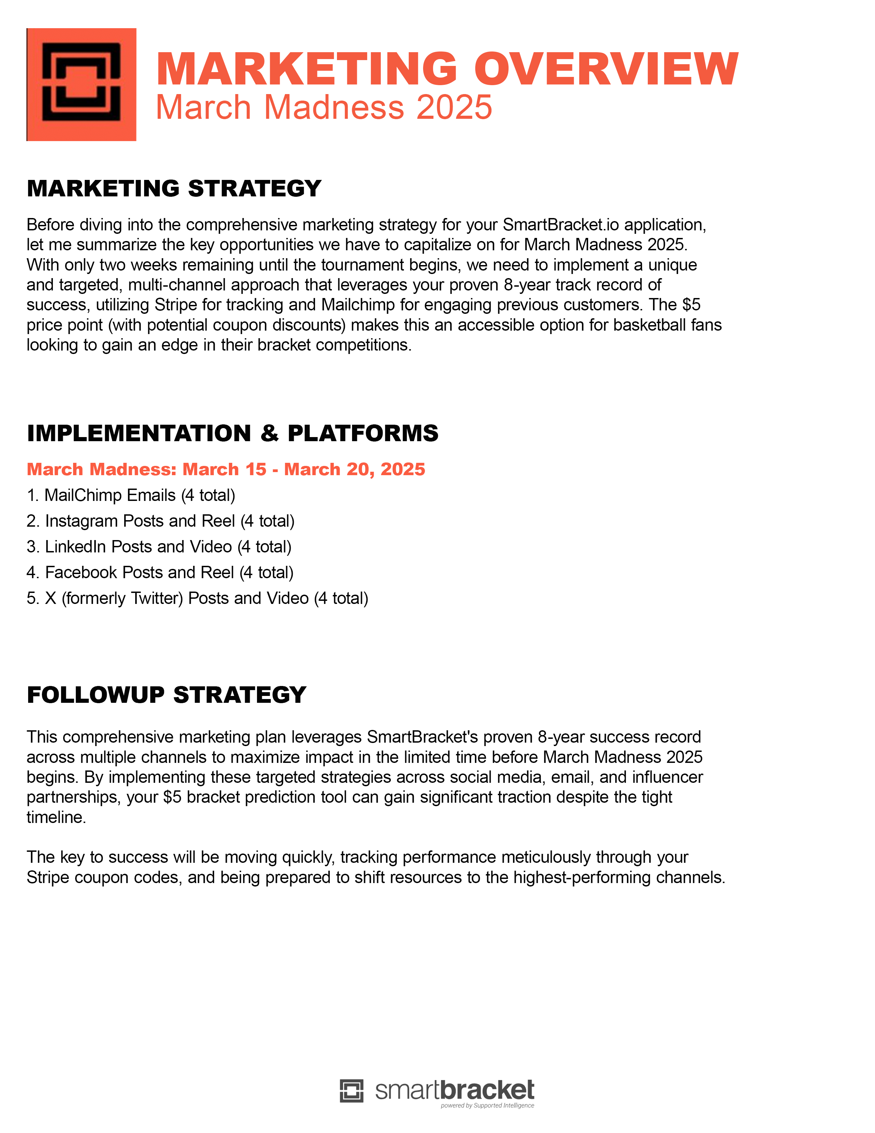

**APPENDIX 2: Email Outreach Activity (2025 Results)**

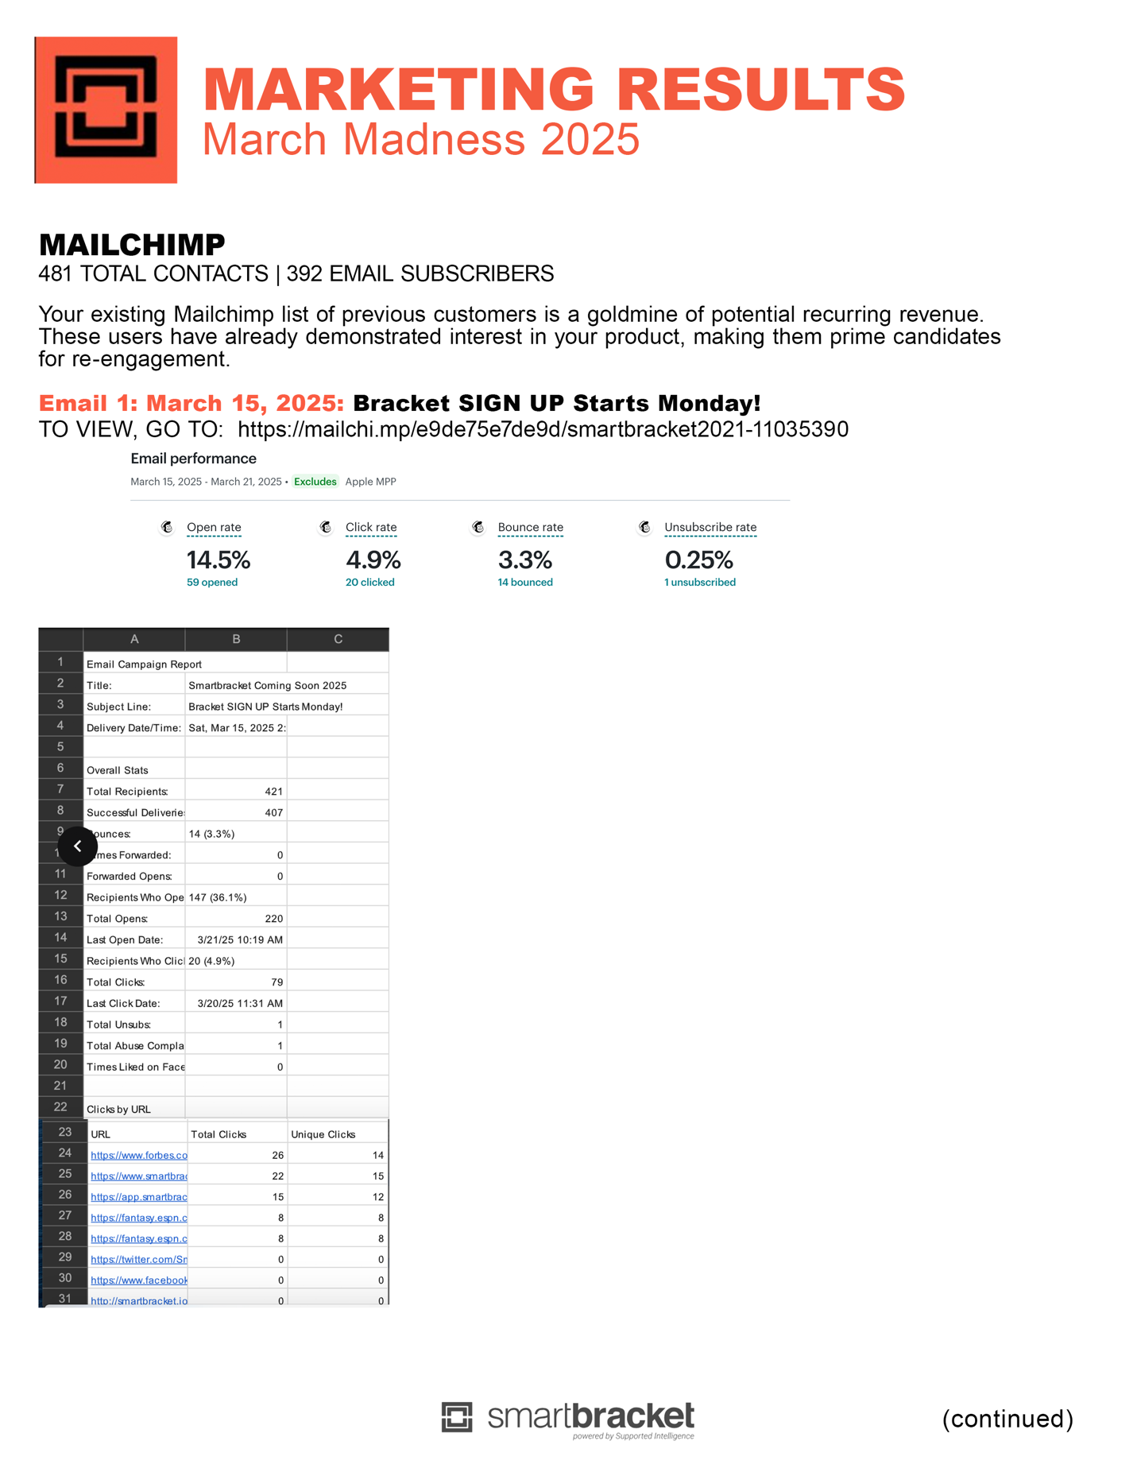

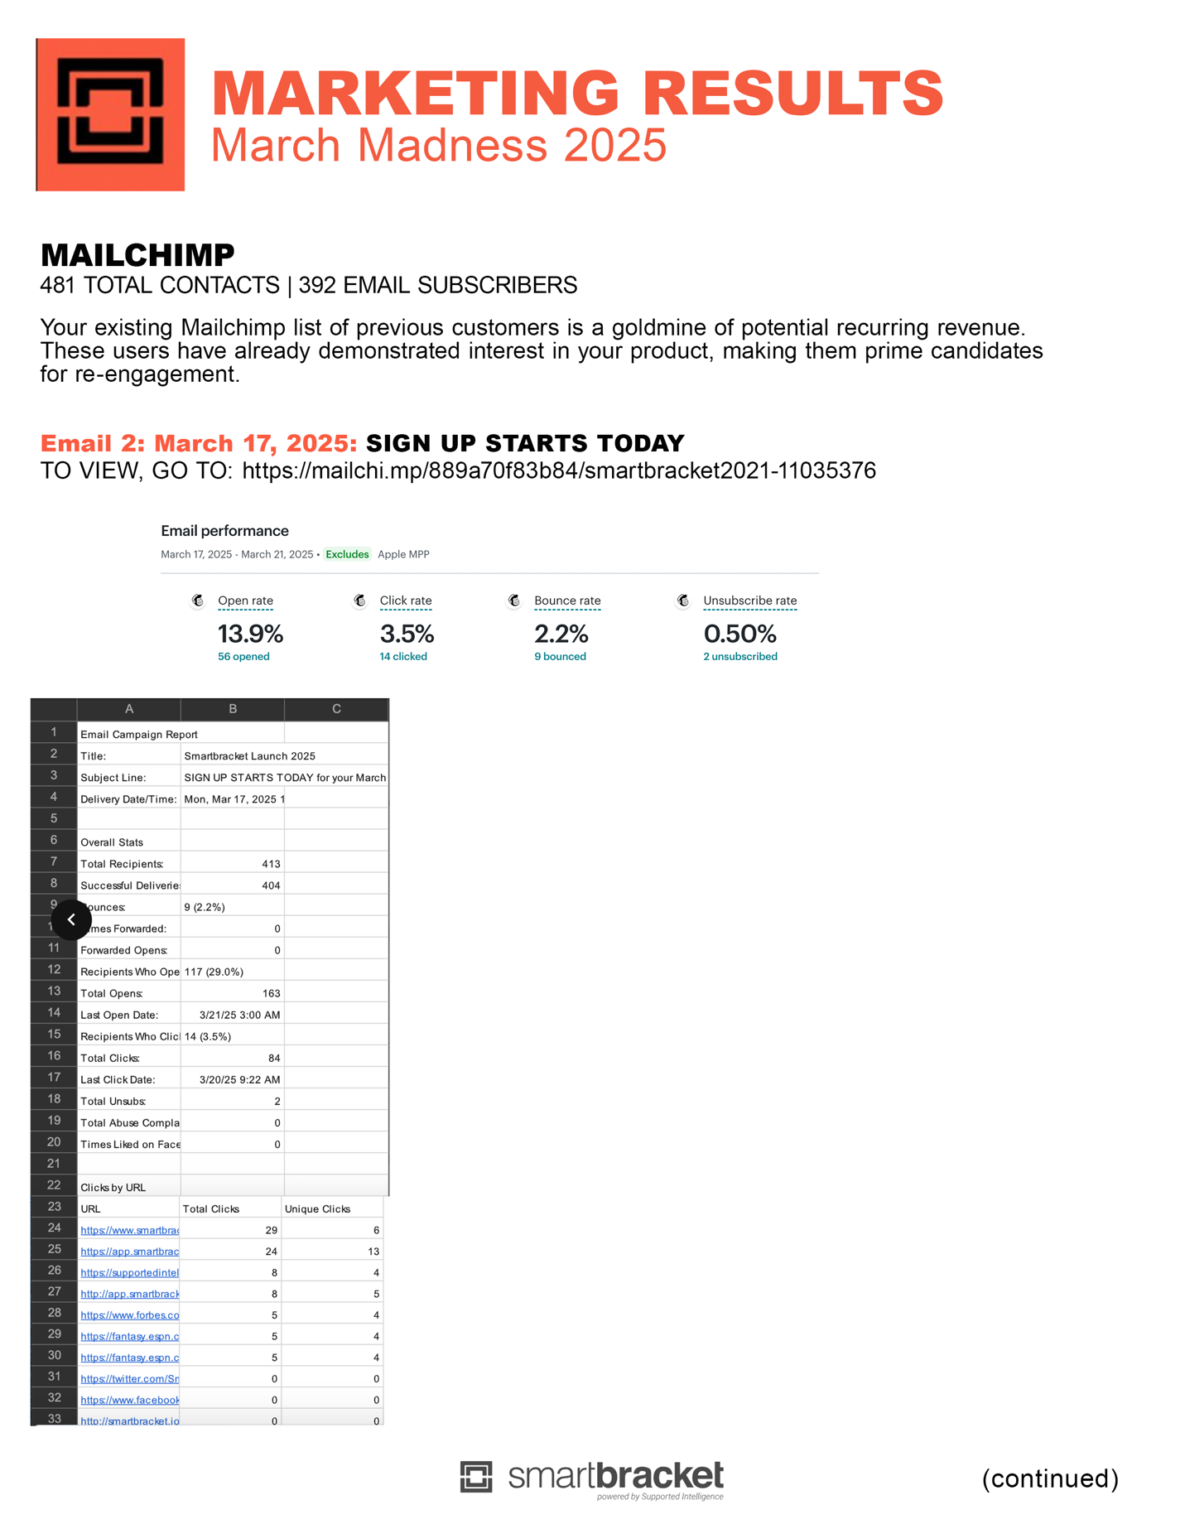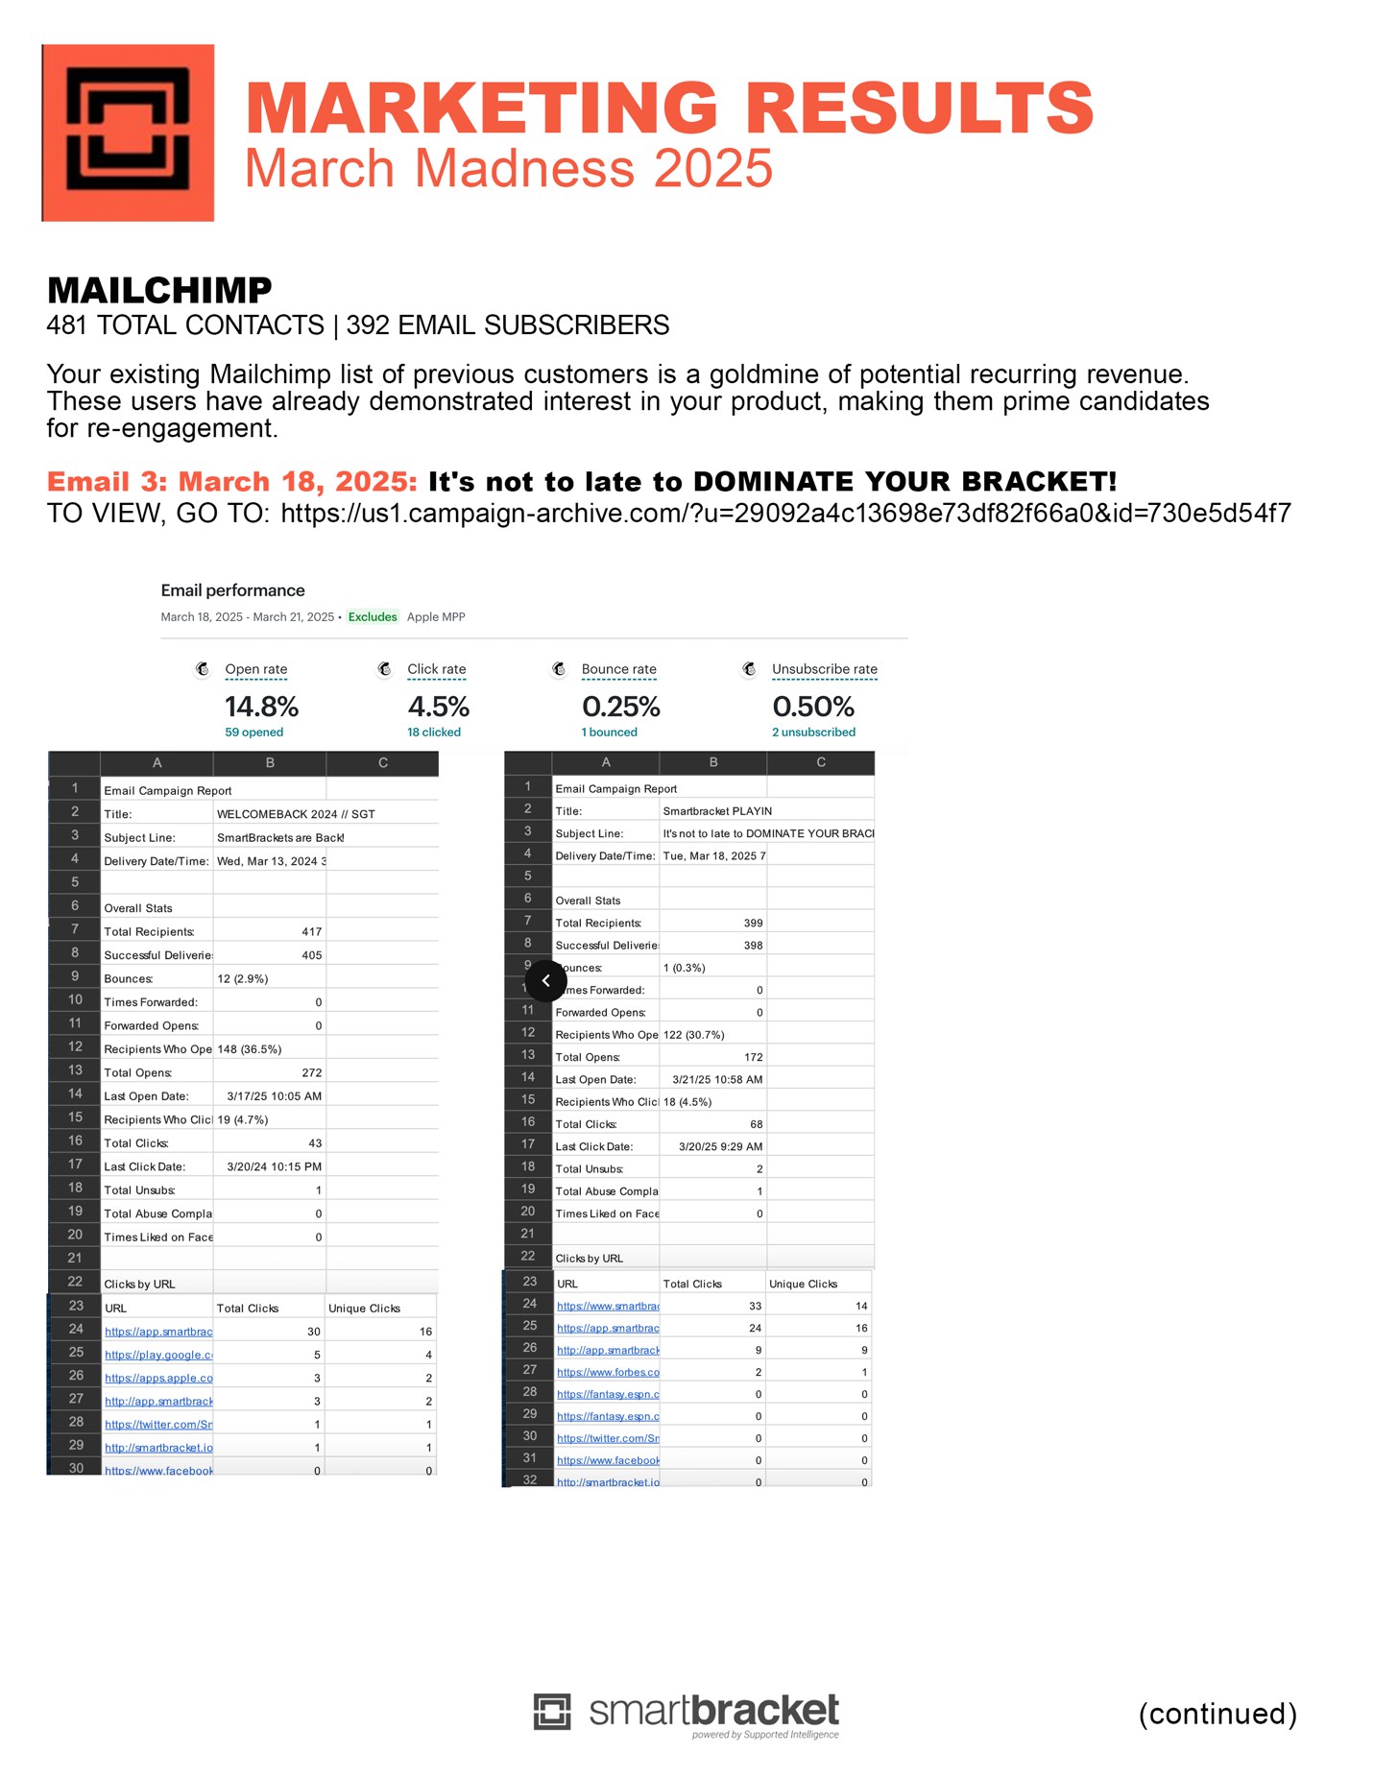

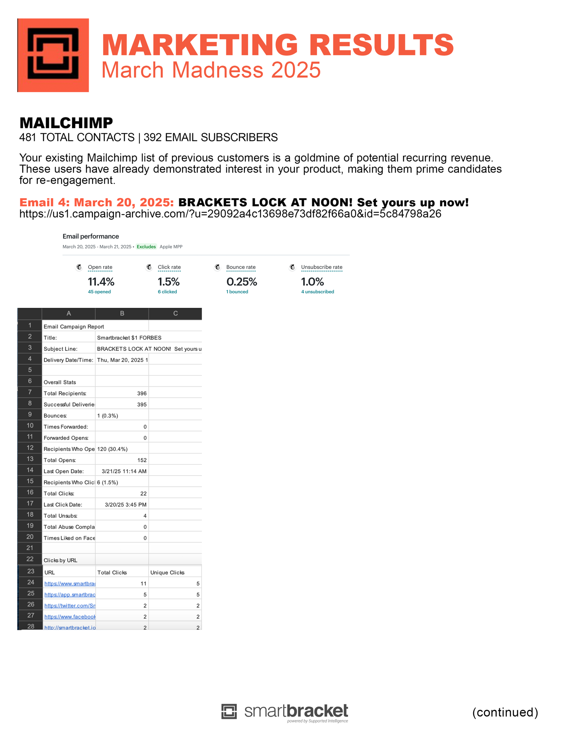

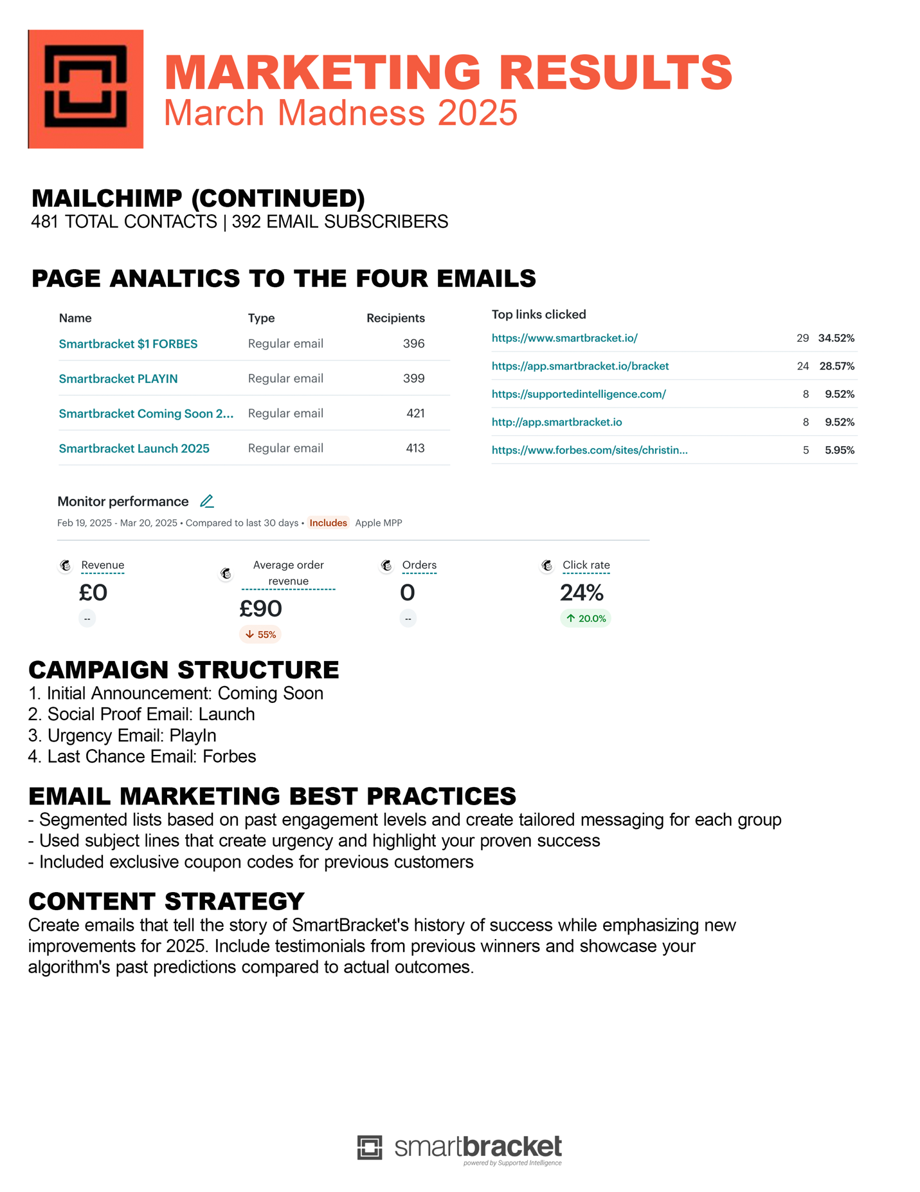

**APPENDIX 3: LinkedIn Outreach Activity (2025 Results)**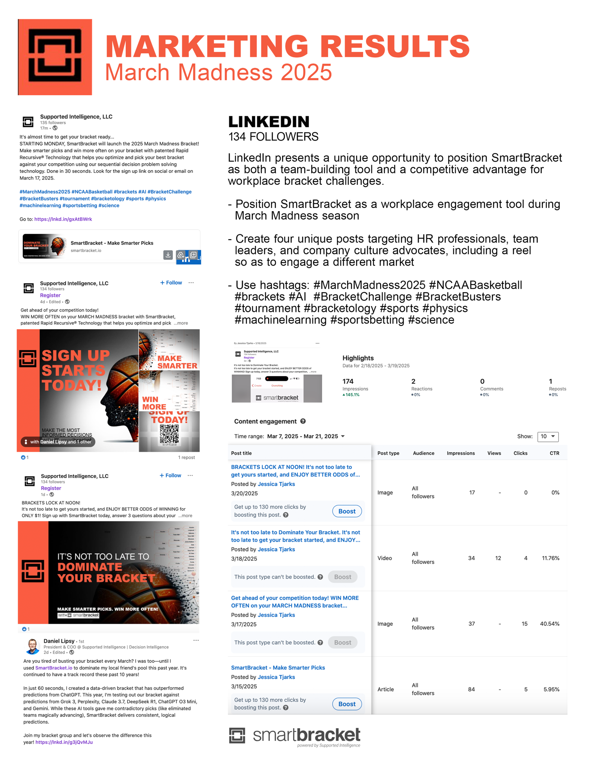

**APPENDIX 4: Instagram Outreach Activity (2025 Results)**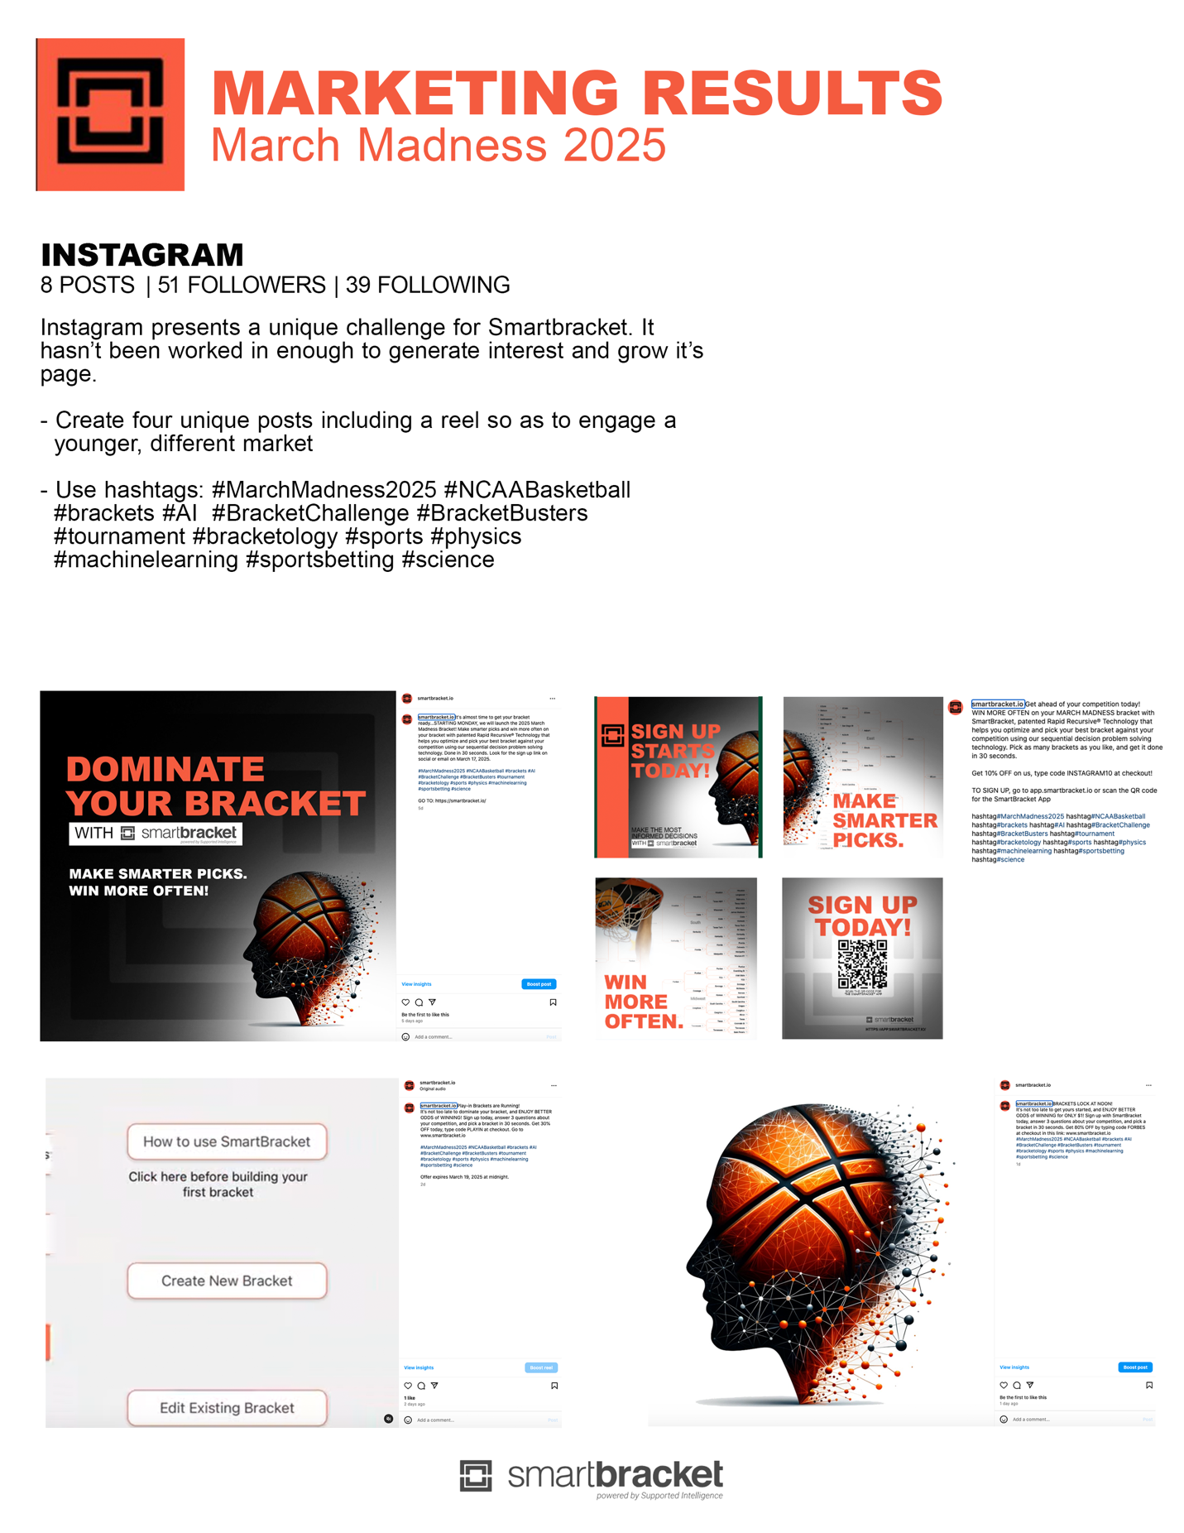

**APPENDIX 5: Facebook/Meta Outreach Activity (2025 Results)**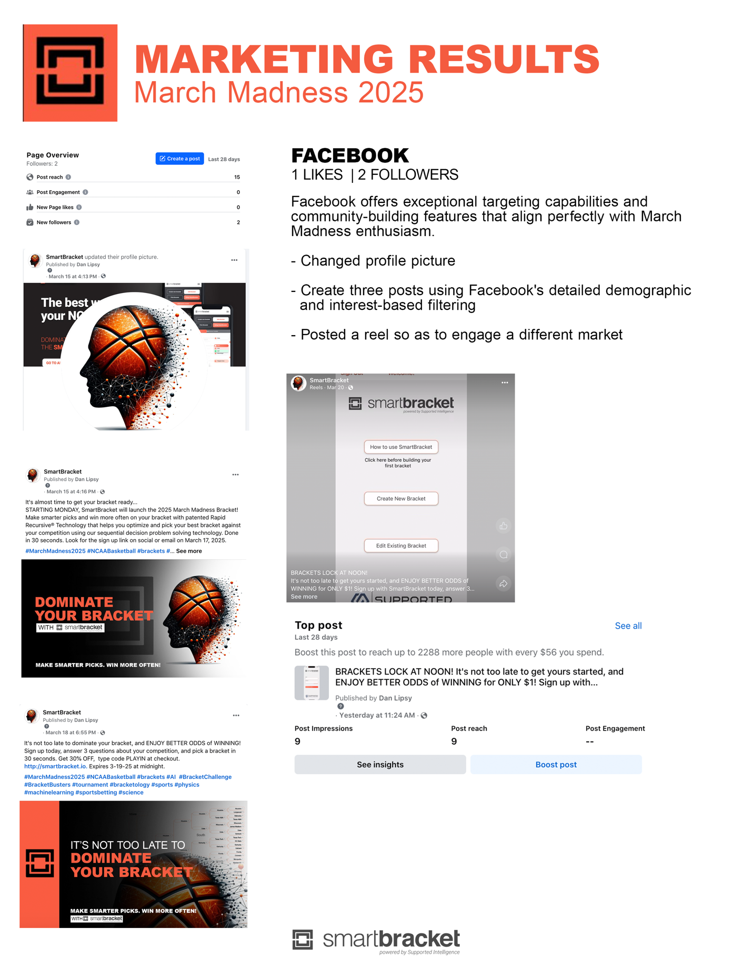

**APPENDIX 6: Twitter/X Outreach Activity (2025 Results)**

